Calculating Family Expenses using Service Now

1. Setting up Service Now Instance
Sign up for a developer account at developer.servicenow.com.
Go to Personal Developer Instance → Request Instance and fill in the required details.
Once your instance is ready, log in using the provided credentials to access Service Now.

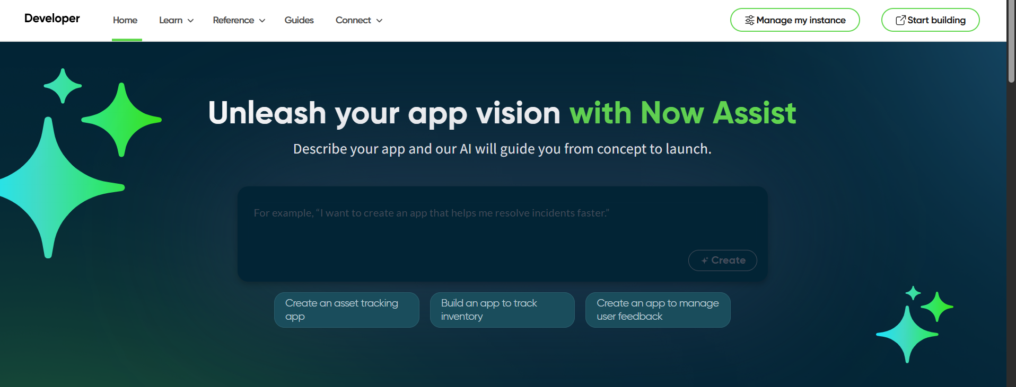
2. Creation of New Update Set
In the filter navigator, search Local Update Set → click New.
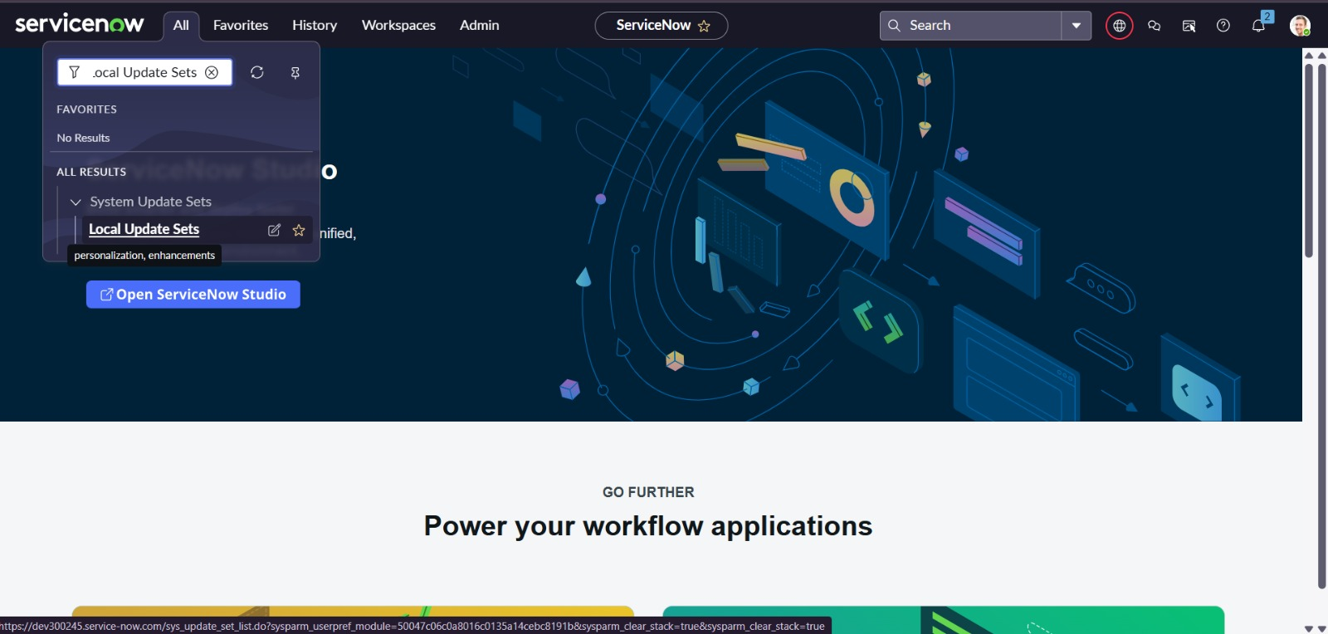

Enter Name: Family Expenses, then click Submit and Make Current.

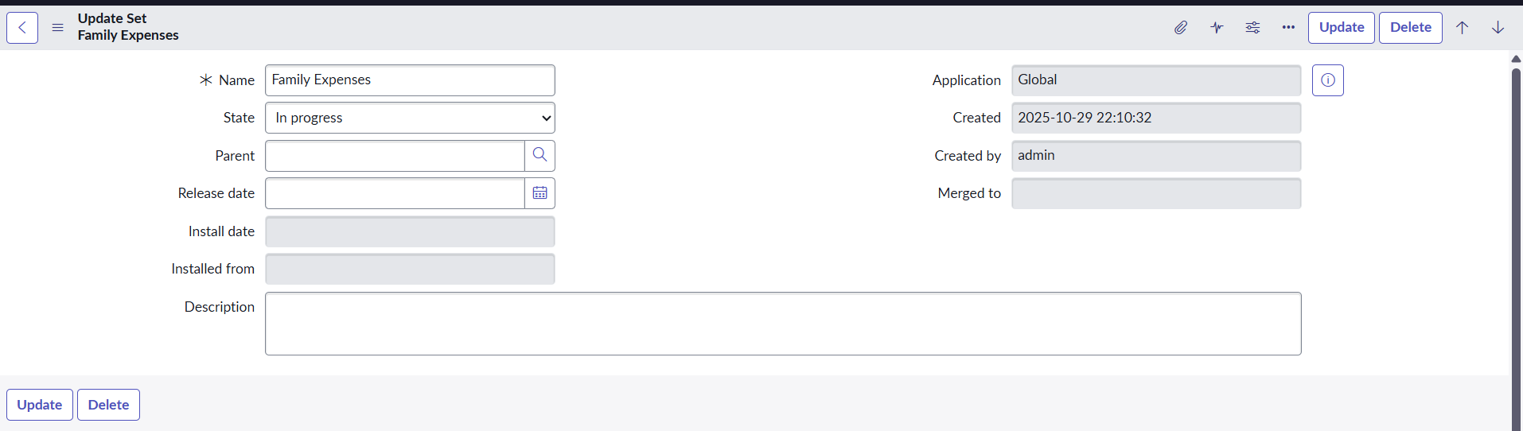

3.Creation of Family Expenses Table
In the filter navigator, search Tables → click New.
Enter Label: Family Expenses, Menu Name: Family Expenditure, then right-click the header and select Save.

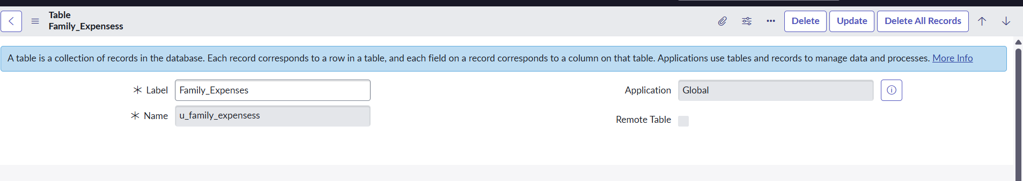

4.Creation of Columns (Fields)

Add new rows under Columns with the following details:
- Number – String
- Date – Date
- Amount – Integer
- Expense Details – String (Max length: 800)
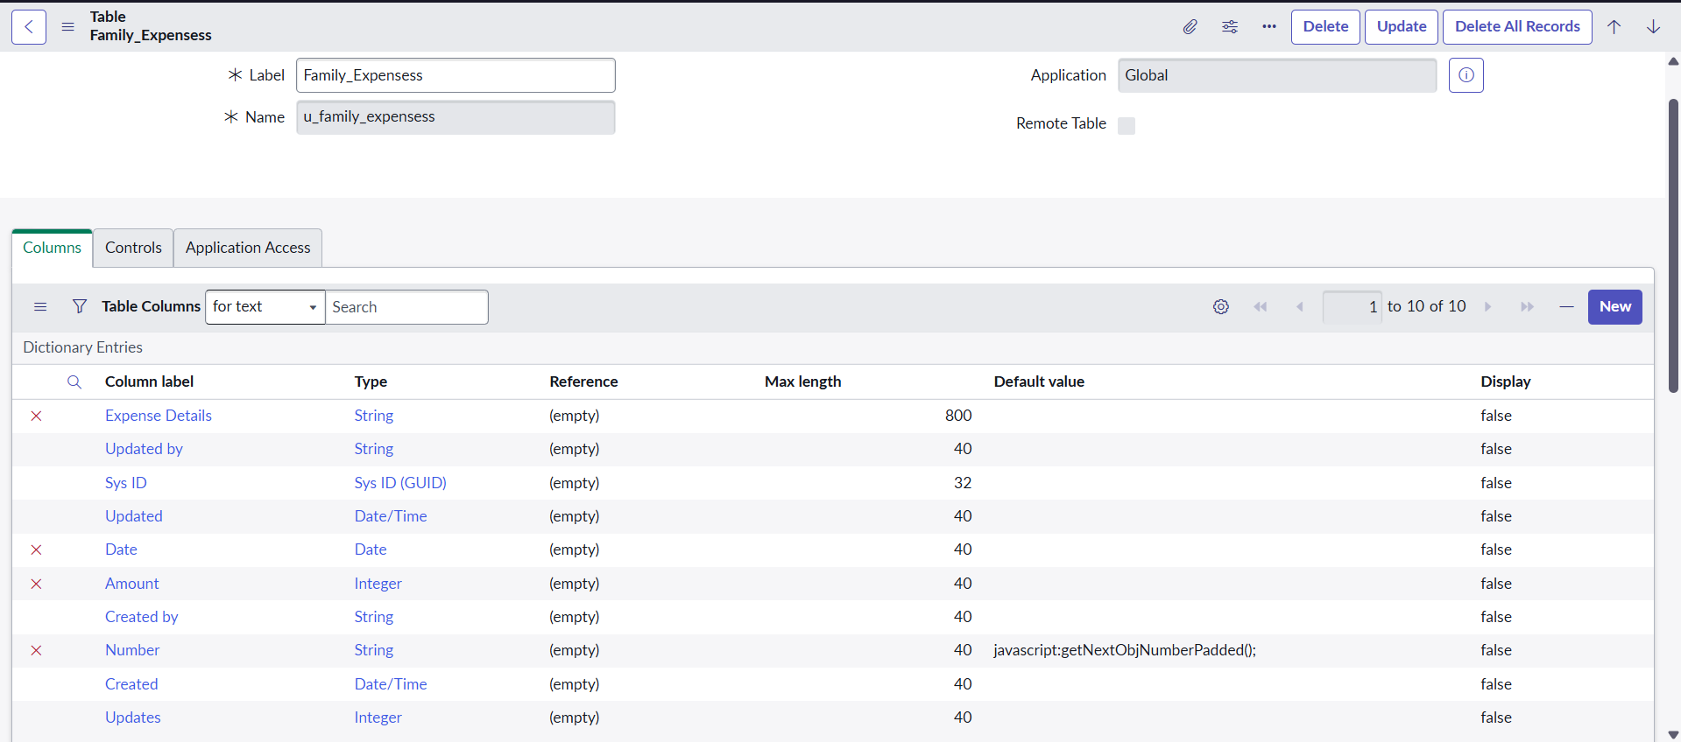

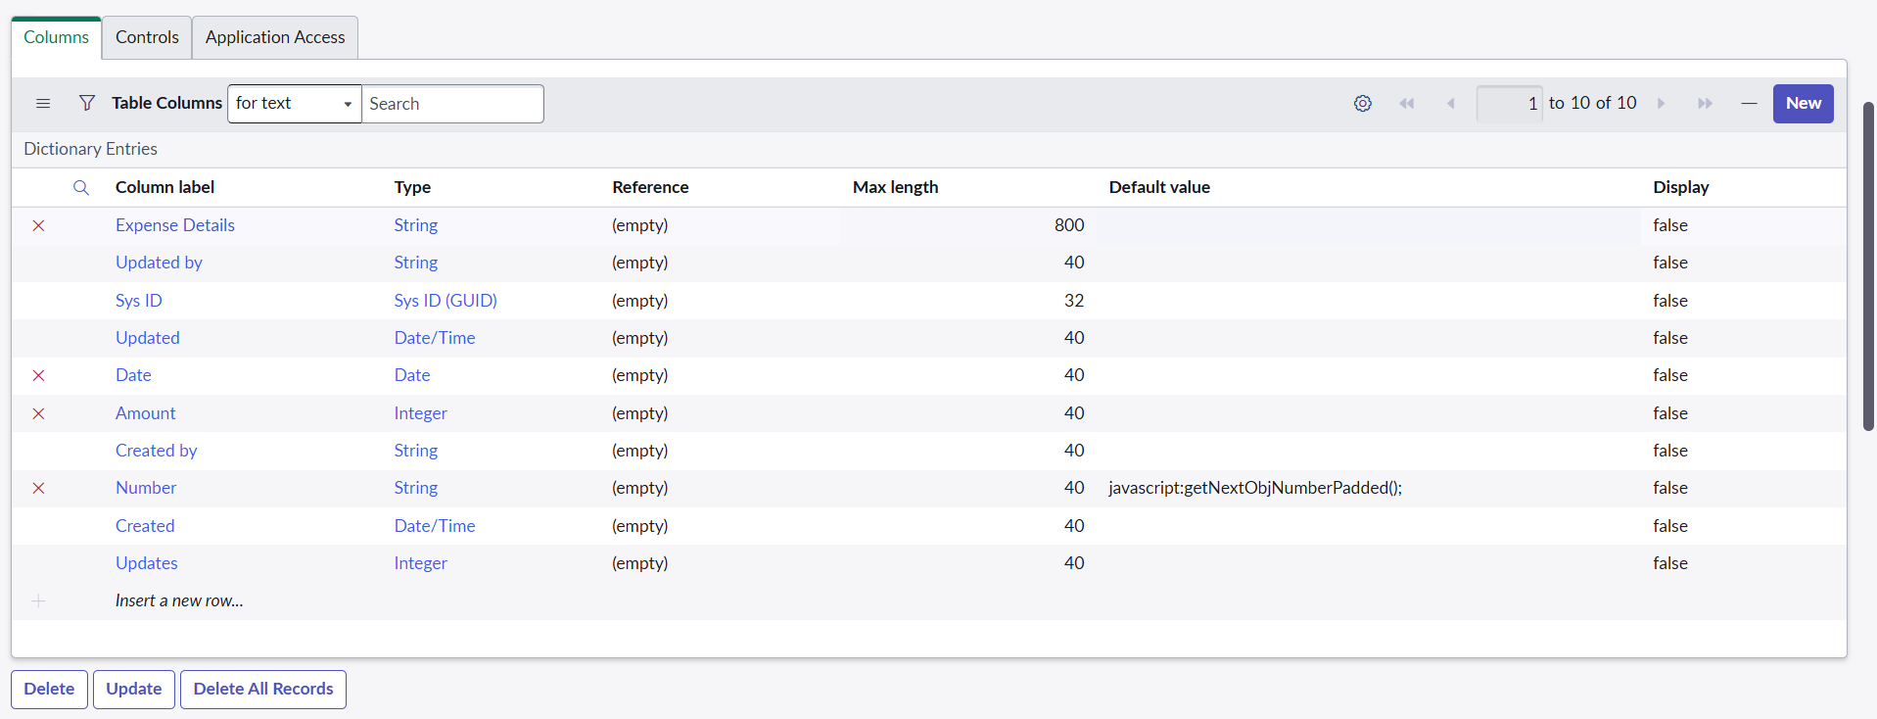

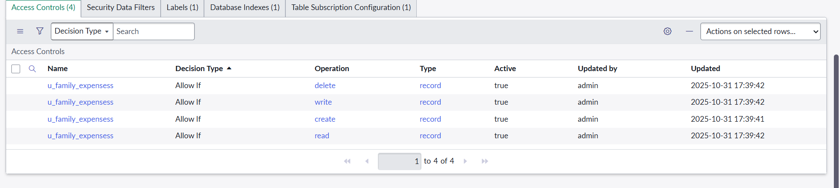
Right-click the header and select Save.

4. Making Number Field an Auto-Number

Open the Number field → Advanced view.
Check Use dynamic default and select Get Next Padded Number, then click Update.

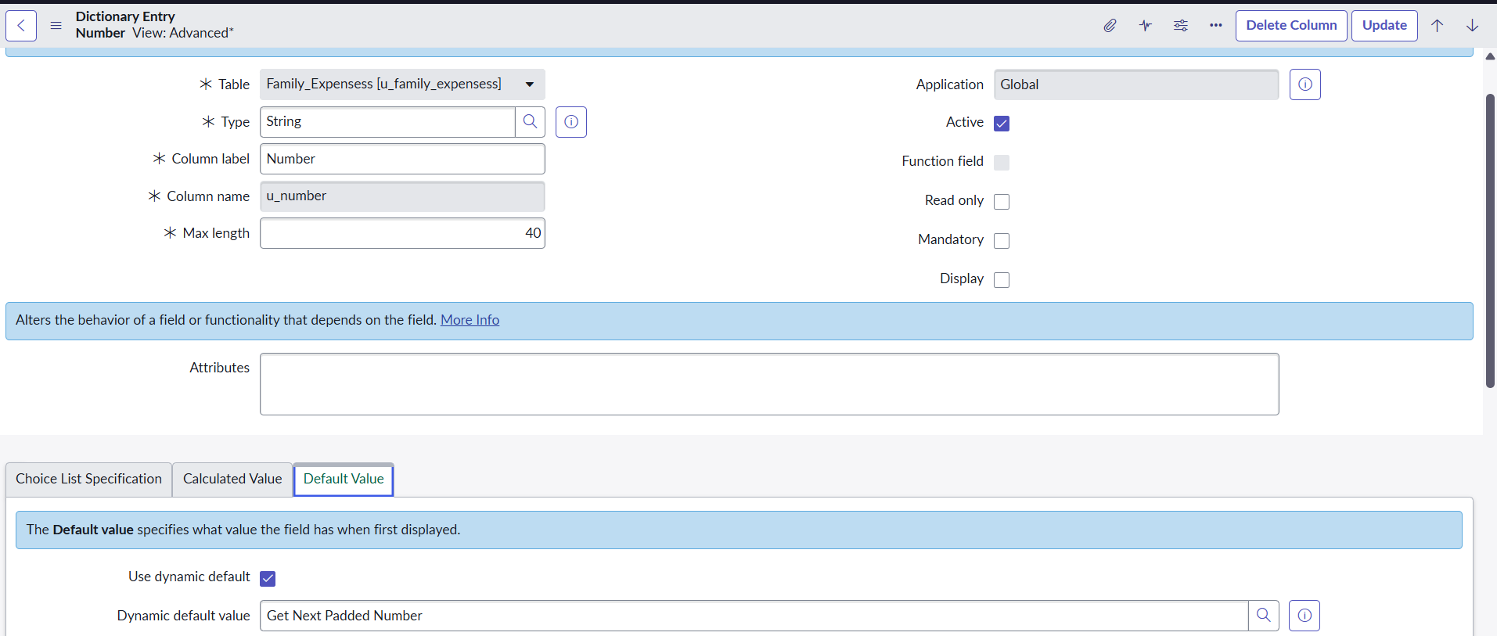

Search Number Maintenance → click New.
Set Table: Family Expenses, Prefix: MFE, and click Submit.

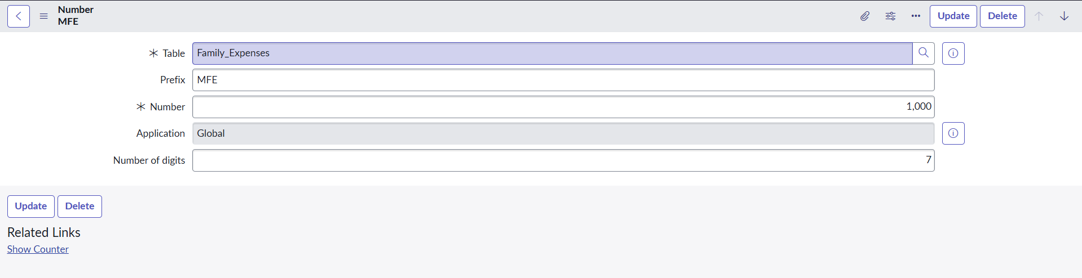

5. Configure the Form
Search Family Expenses and open it.
Click New, then right-click the header → Configure → Form Design.
Arrange fields as needed.
Set Number as Read-only and make Date and Amount Mandatory.
Click Save.

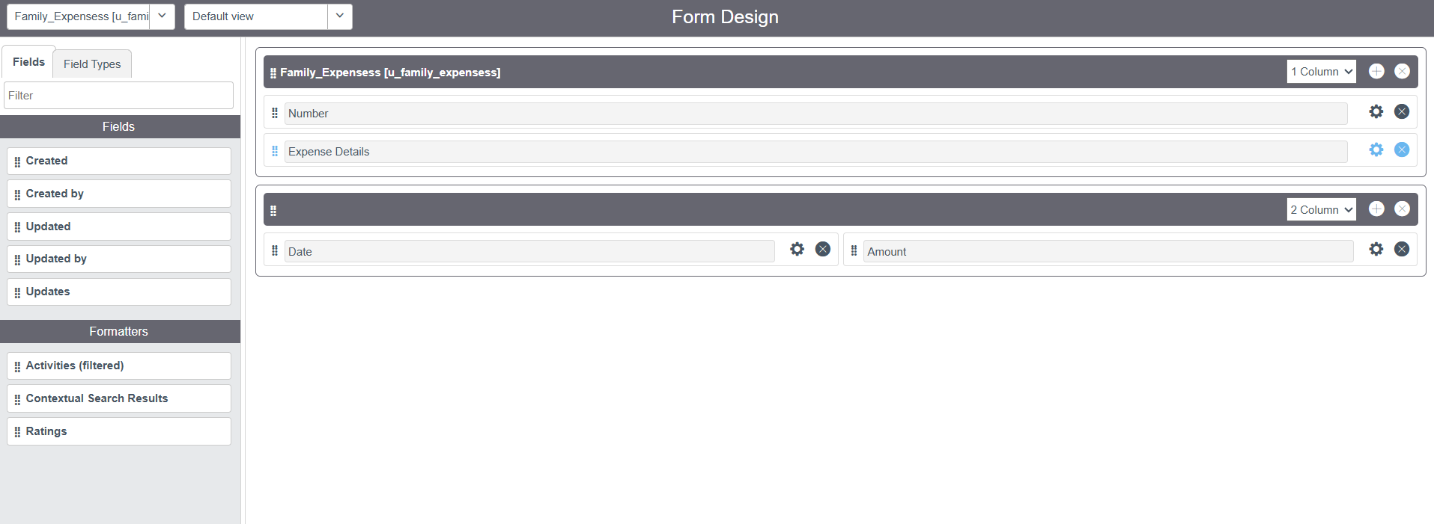

6.Creation of Daily Expenses Table
Search Tables → click New.
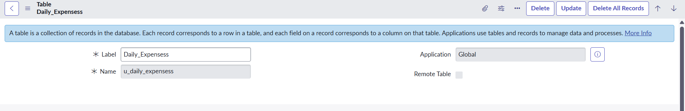

Enter Label: Daily Expenses, add to Menu: Family Expenditure, then right-click the header and select Save.

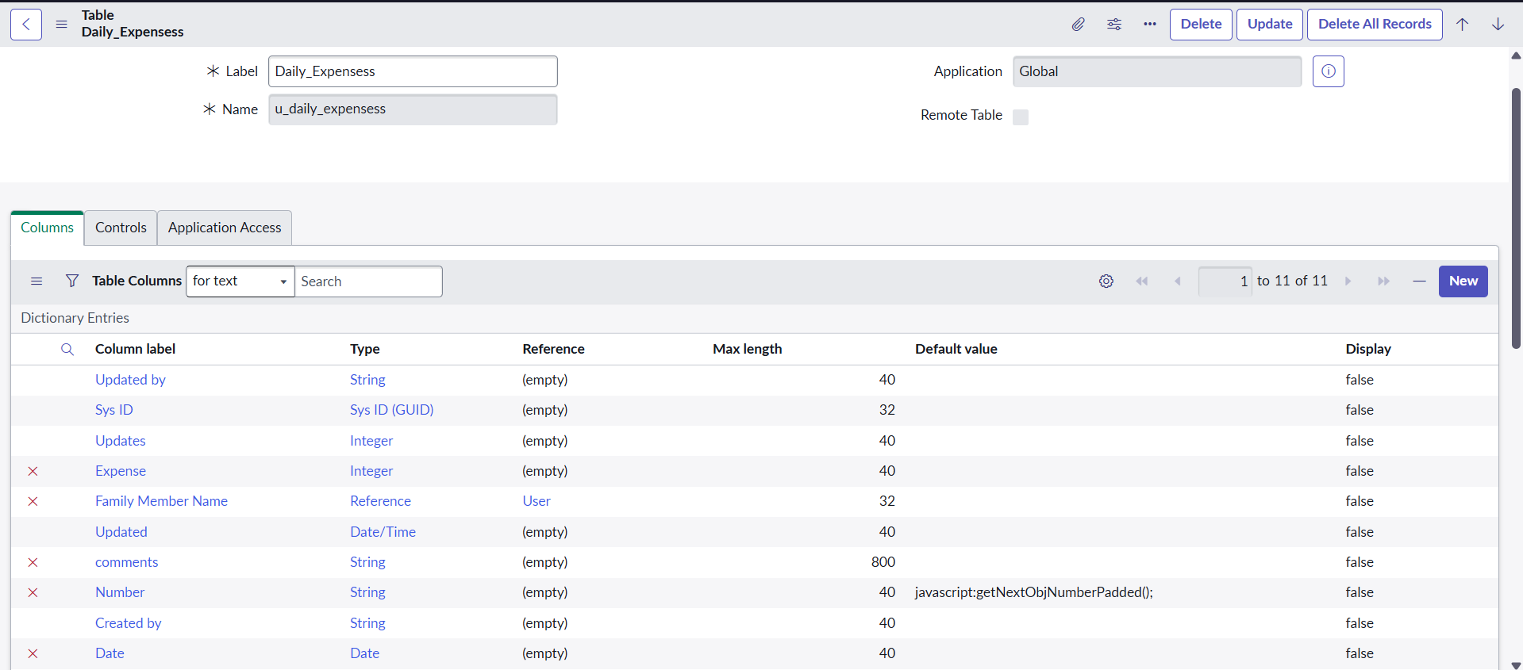
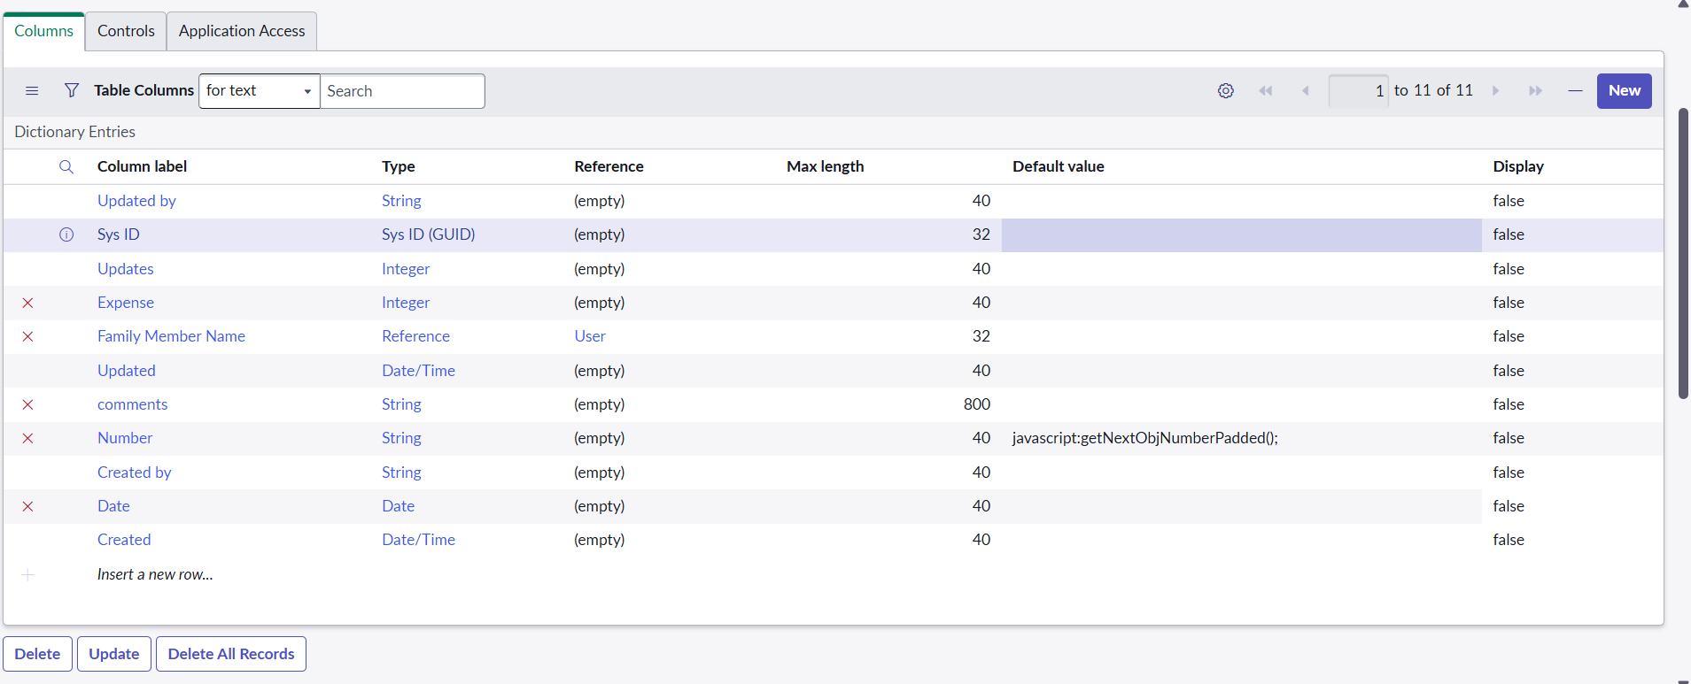
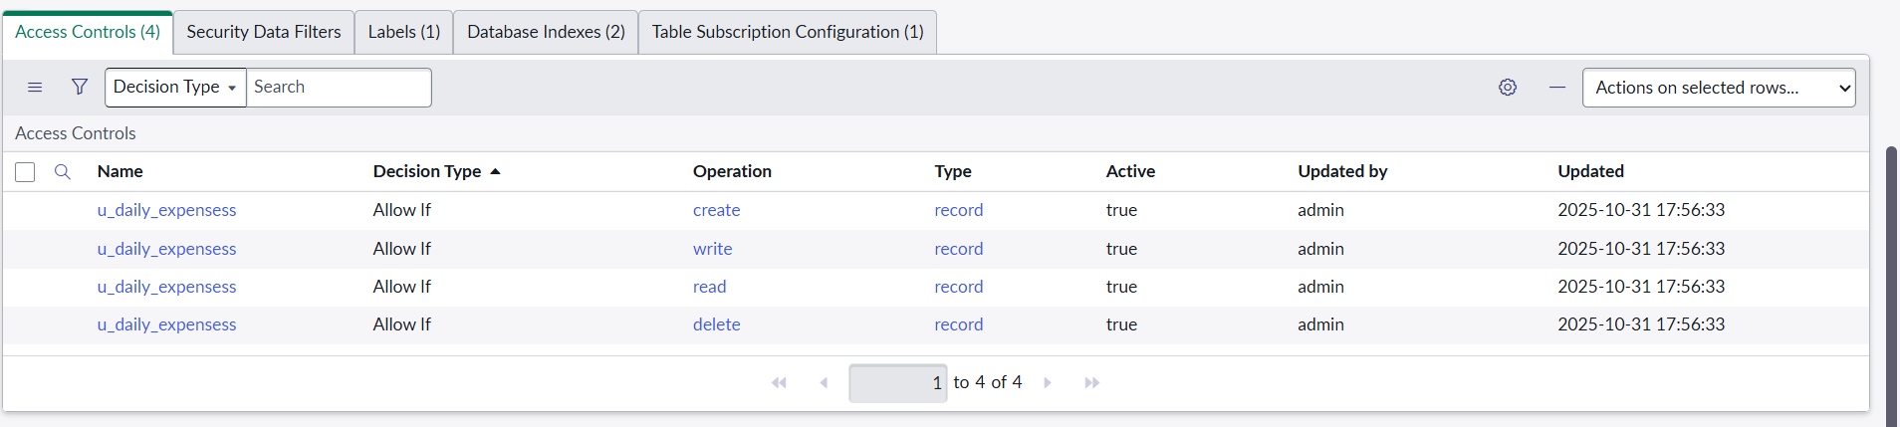

7.Making Number Field an Auto-Number

Open the Number field → Advanced view.
Enable Use dynamic default and choose Get Next Padded Number, then click Update

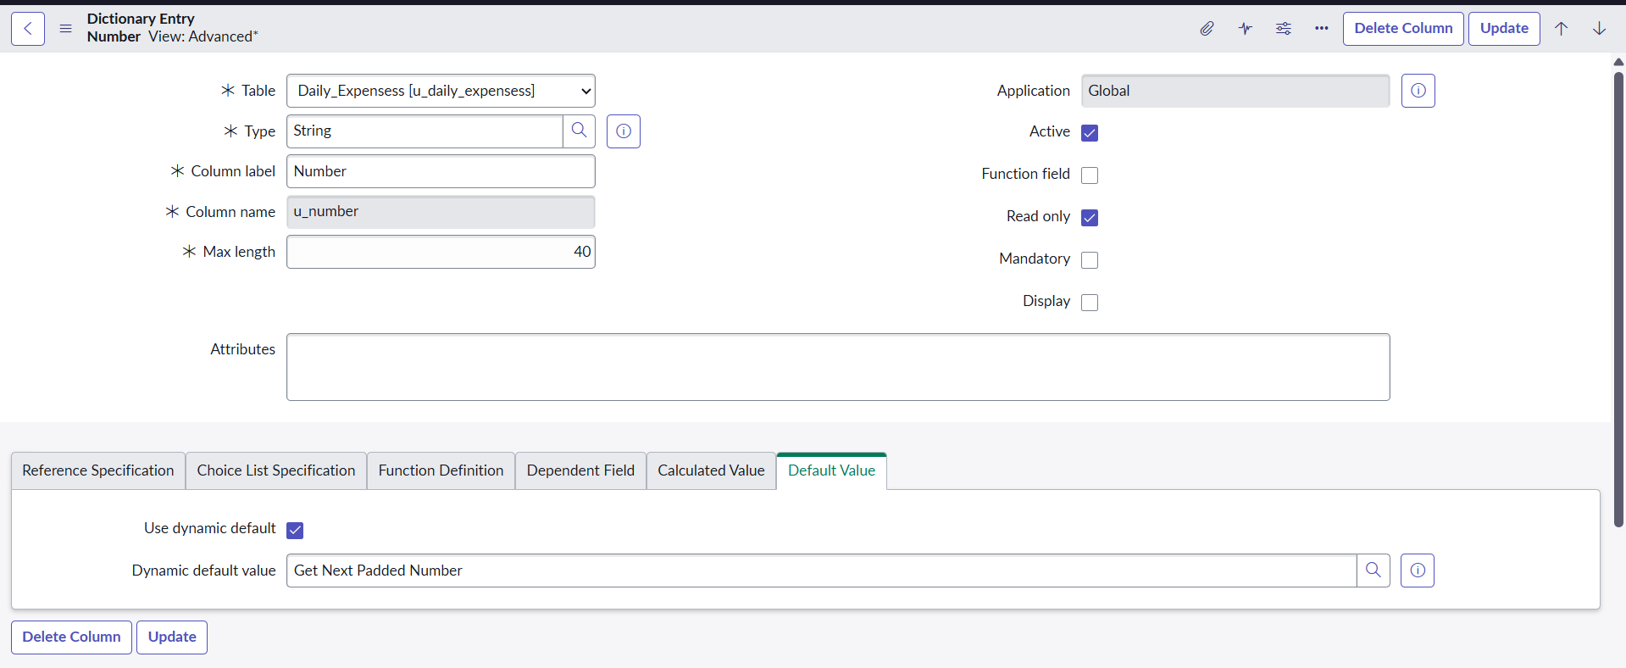
Search Number Maintenance → New.
Set Table: Daily Expenses, Prefix: DFE, and click Submit.

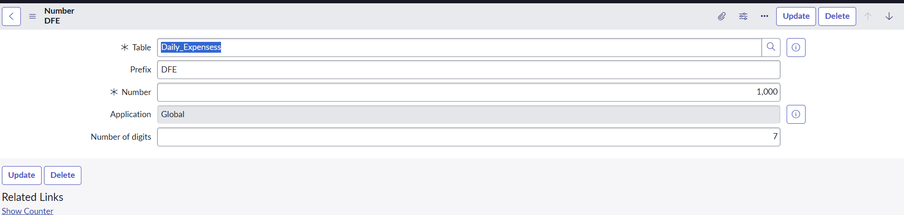

8.Configure the Form

Search Daily Expenses and open it.
Click New, then right-click the header → Configure → Form Design.
Arrange fields as needed.
Set Number as Read-only and make Date and Family Member Name Mandatory.
Click Save.

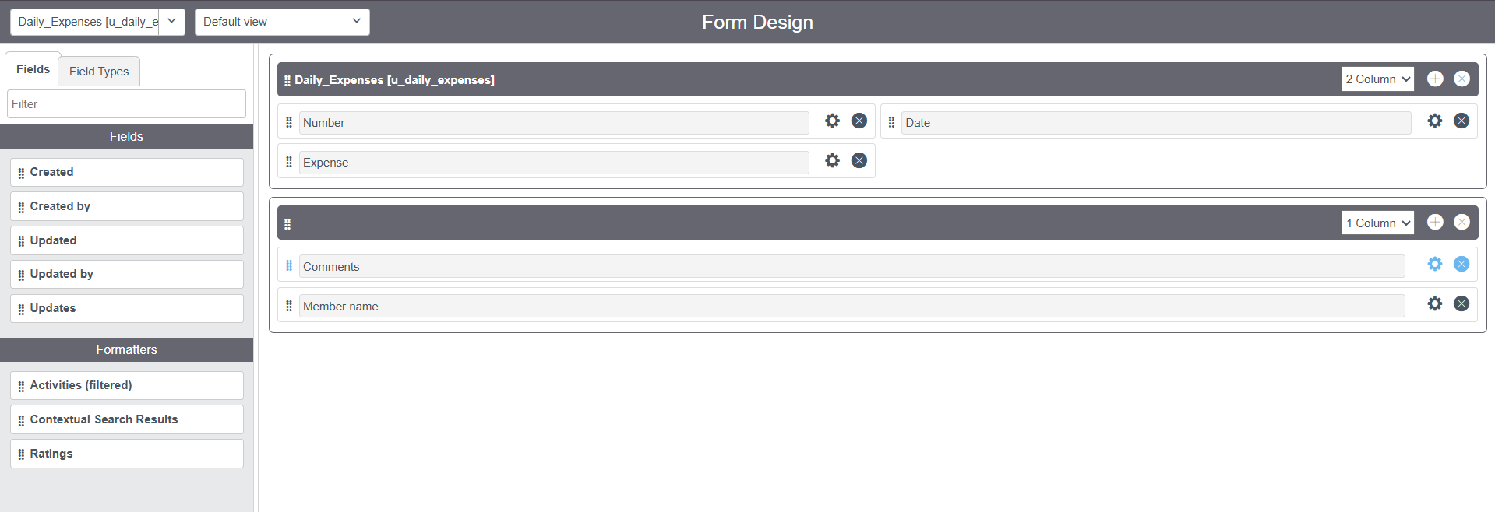

9.Creating Relationship Between Tables

Search Relationships → click New.
Set Name: Daily Expenses, Applies to Table: Family Expenses, Related Table: Daily Expenses, then click Save.

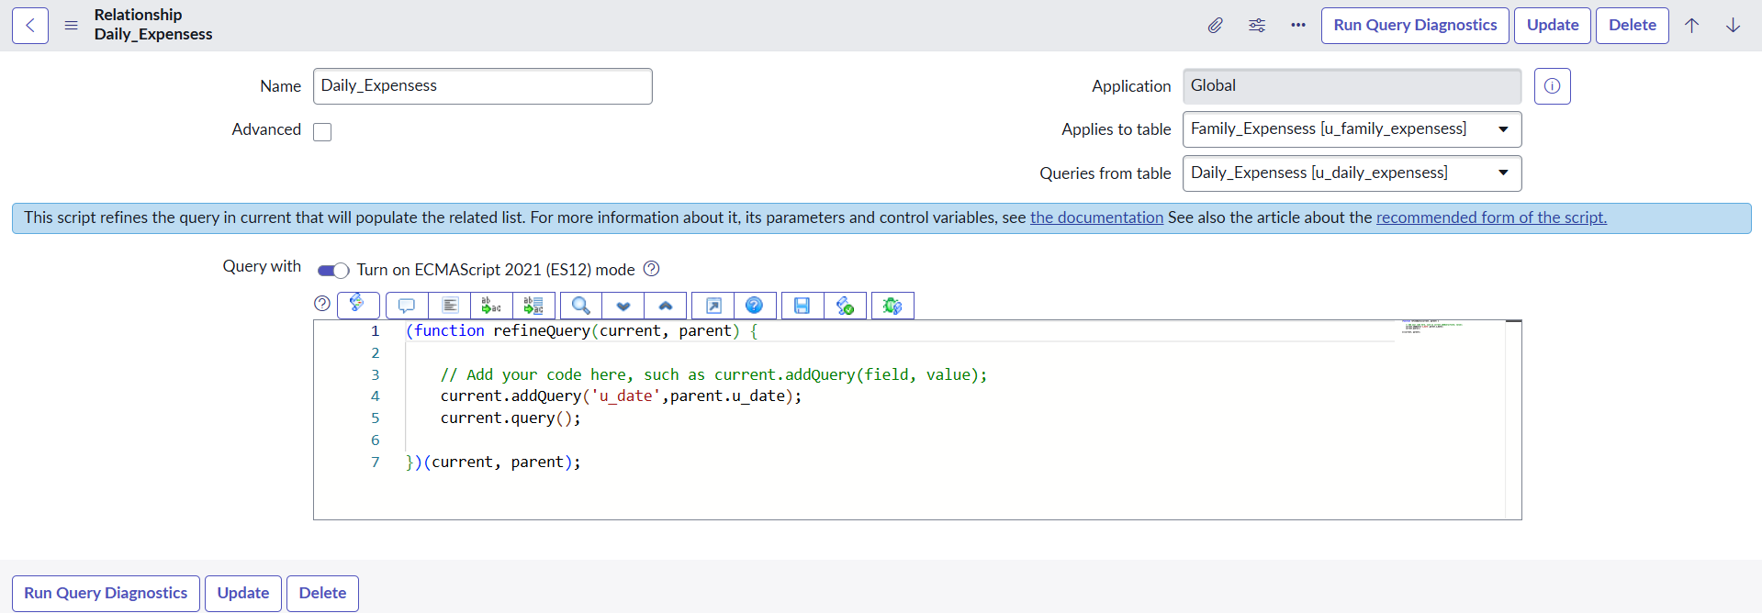

10.Configuring Related List

Open Family Expenses → New → Configure > Related Lists → add Daily Expenses → Save.

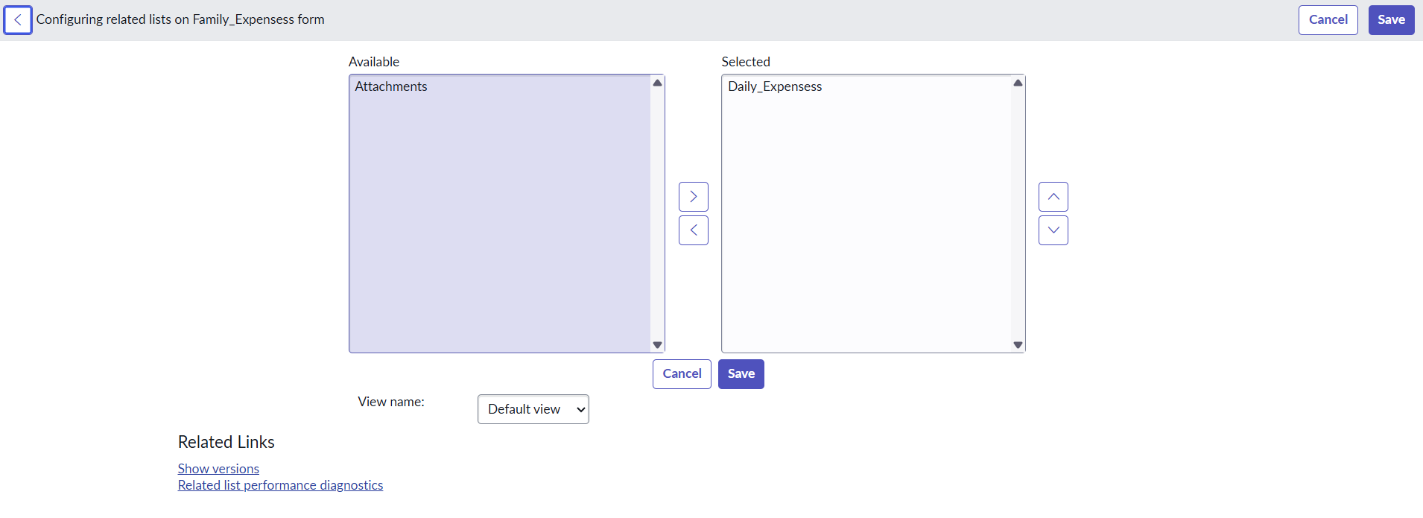

11.Business Rule Creation

Navigate to All → Business Rules → New.
Name: Family Expenses BR
Table: Daily Expenses
Add query: required
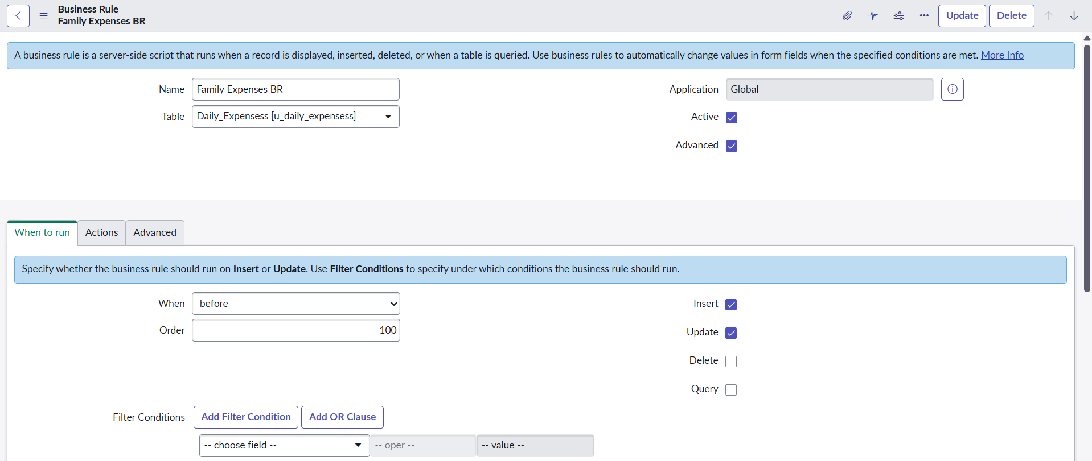

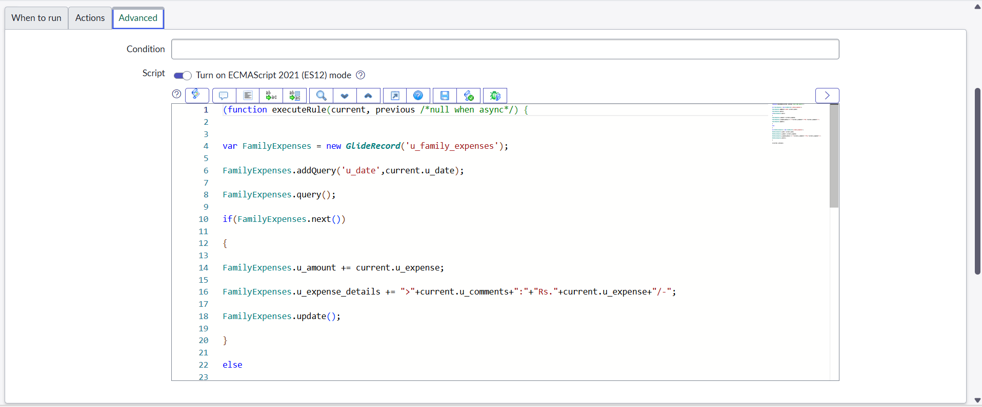

12.Configure Relationship

Go to All → Relationships and open Daily Expenses Relationship.
Set Applies to table: Family Expenses.
Add Query:
(function refine Query (current, parent) {
current. add Query('update', parent. u_date);
current. query ();
}) (current, parent);

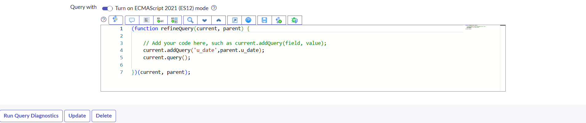

Update the Relationships by clicking on update.

- Built in Service Now to manage family spending.
- Daily Expenses table records:
  - Date, Amount, Comments, Family Member
- Family Expenses table shows:
  - Total spent per date, with summary
- Tables are linked:
  - Daily entries update family totals automatically
- Helps track spending and keep financial records organized.

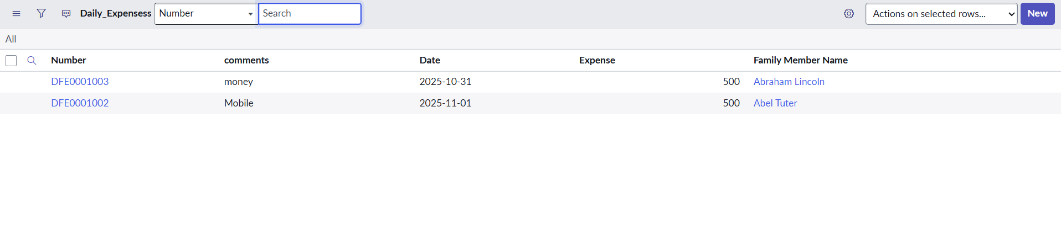
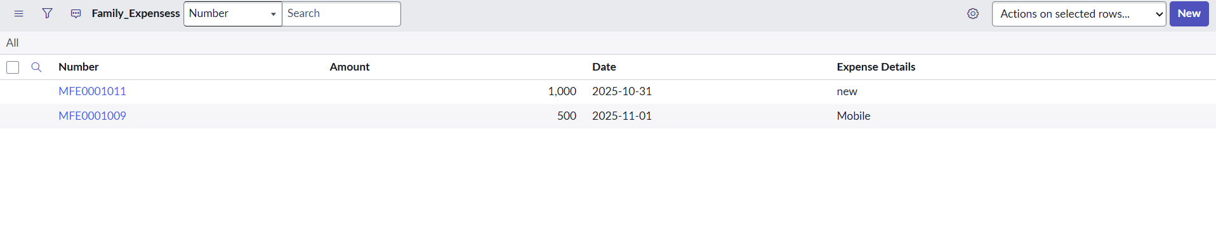
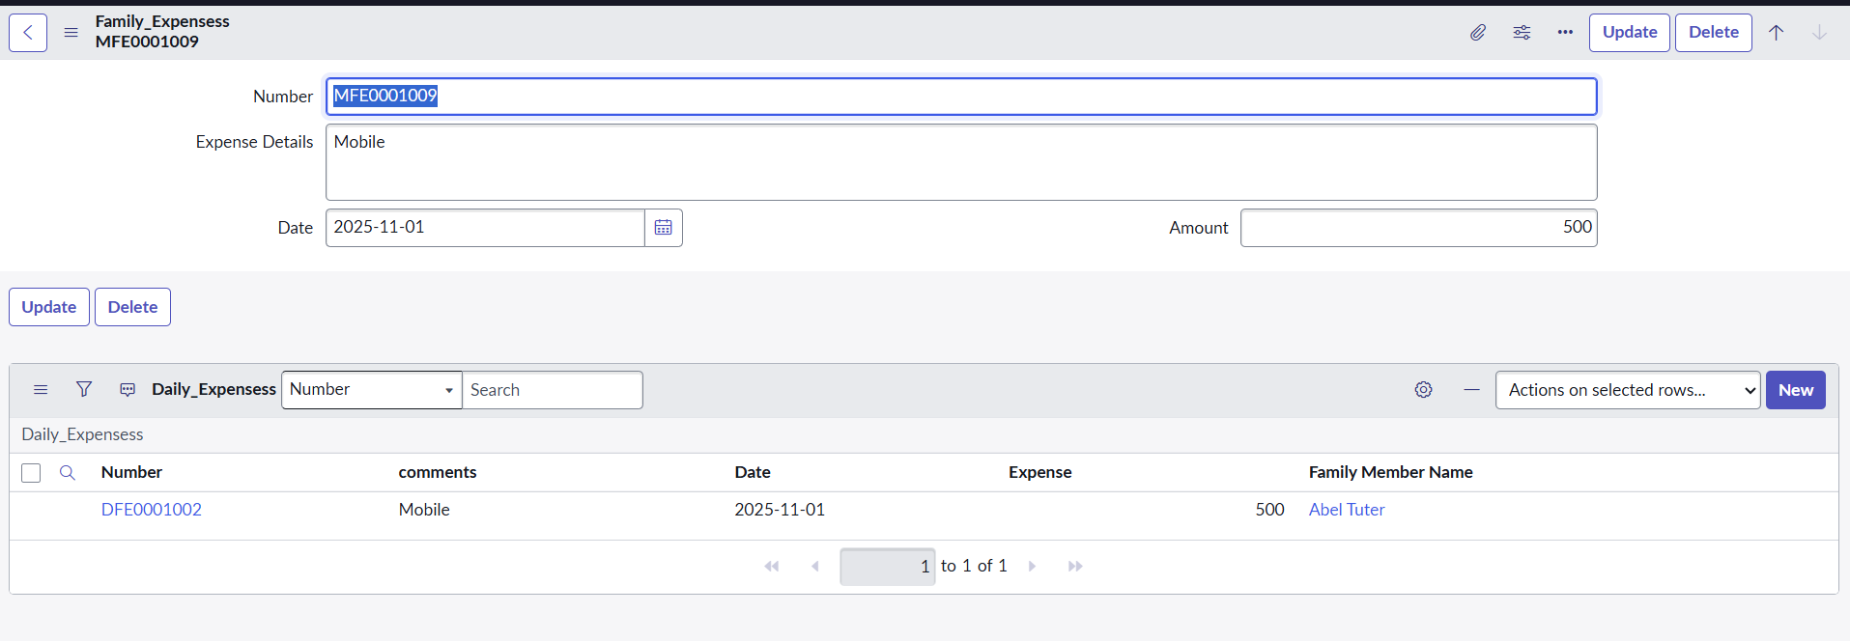

Conclusion:

In conclusion, the Family Expenses Calculation System built on Service Now provides an efficient and organized way to manage household finances. By leveraging Service Now automation and data management capabilities, the system simplifies expense tracking, ensures accuracy, and offers real-time insights into family spending patterns. This project not only enhances financial transparency but also promotes better budgeting and informed decision-making—ultimately contributing to improved financial stability and well-being for families.

Done By,
Team ID: NM2025TMID06448
Team Leader: N. Revathi Selvam
Team Member: K. Priya Dharshini
Team Member: R. Priya Dharshini
Team Member: A. Rajalakshmi

Thank You!

